# TABLE OF CONTENTS

**Creating Hexagons with area of 10km^2** **1**

**Maintenance** **4**

**Getting a Population Grid:** **4**

**Choropleth Plots:** **6**

# 

# Creating Hexagons with area of 10km^2

For a Hexagon to have 10km^2 area, it’s side length must be **1.961887km**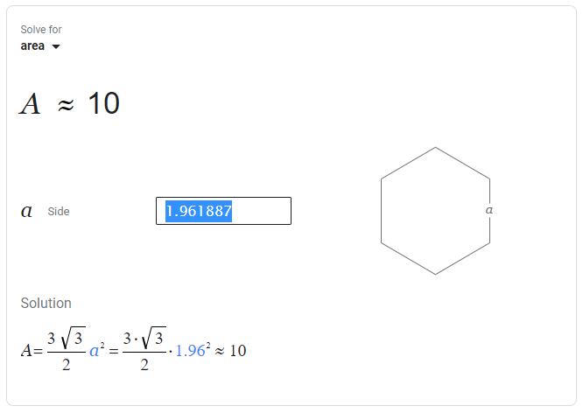

The relationship between km and degree is approximately linear (105.189478986)

Therefore, the formula for km to degree (coordinate) is approximately:

Therefore the correct side length of a hexagon in degrees is : **0.01865098124**

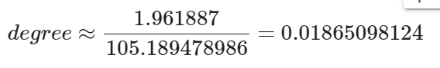

Verifying that my script preserves the Hexagon side length in degrees:

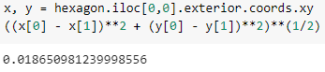

With side length 0.01865098124 my script generates a grid of **46800** hexagons

Now to verify the Hexagon side length in km in our generated Hexagon grid:

The hexagons are all of equal size, so we just pick one Hexagon to verify: <https://www.movable-type.co.uk/scripts/latlong.html>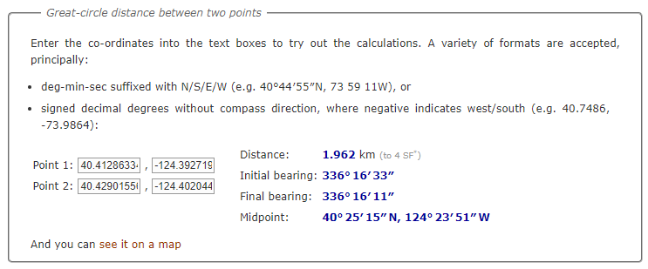

The tool above rounds to 4 sig figs, so 1.962 is correct **(1.961887** rounded**)**

Even if our distance is just 1.962 (not rounded), the area is still very close to 10km^2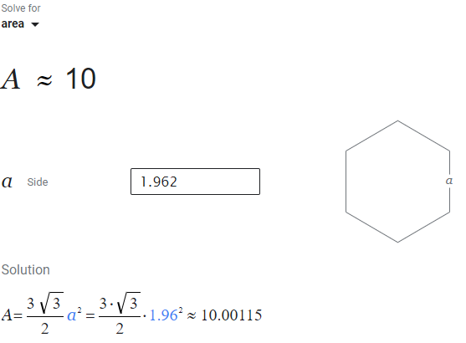

**Figure 1**: Snapshot of grid, if we zoom out, you can’t see the hexagons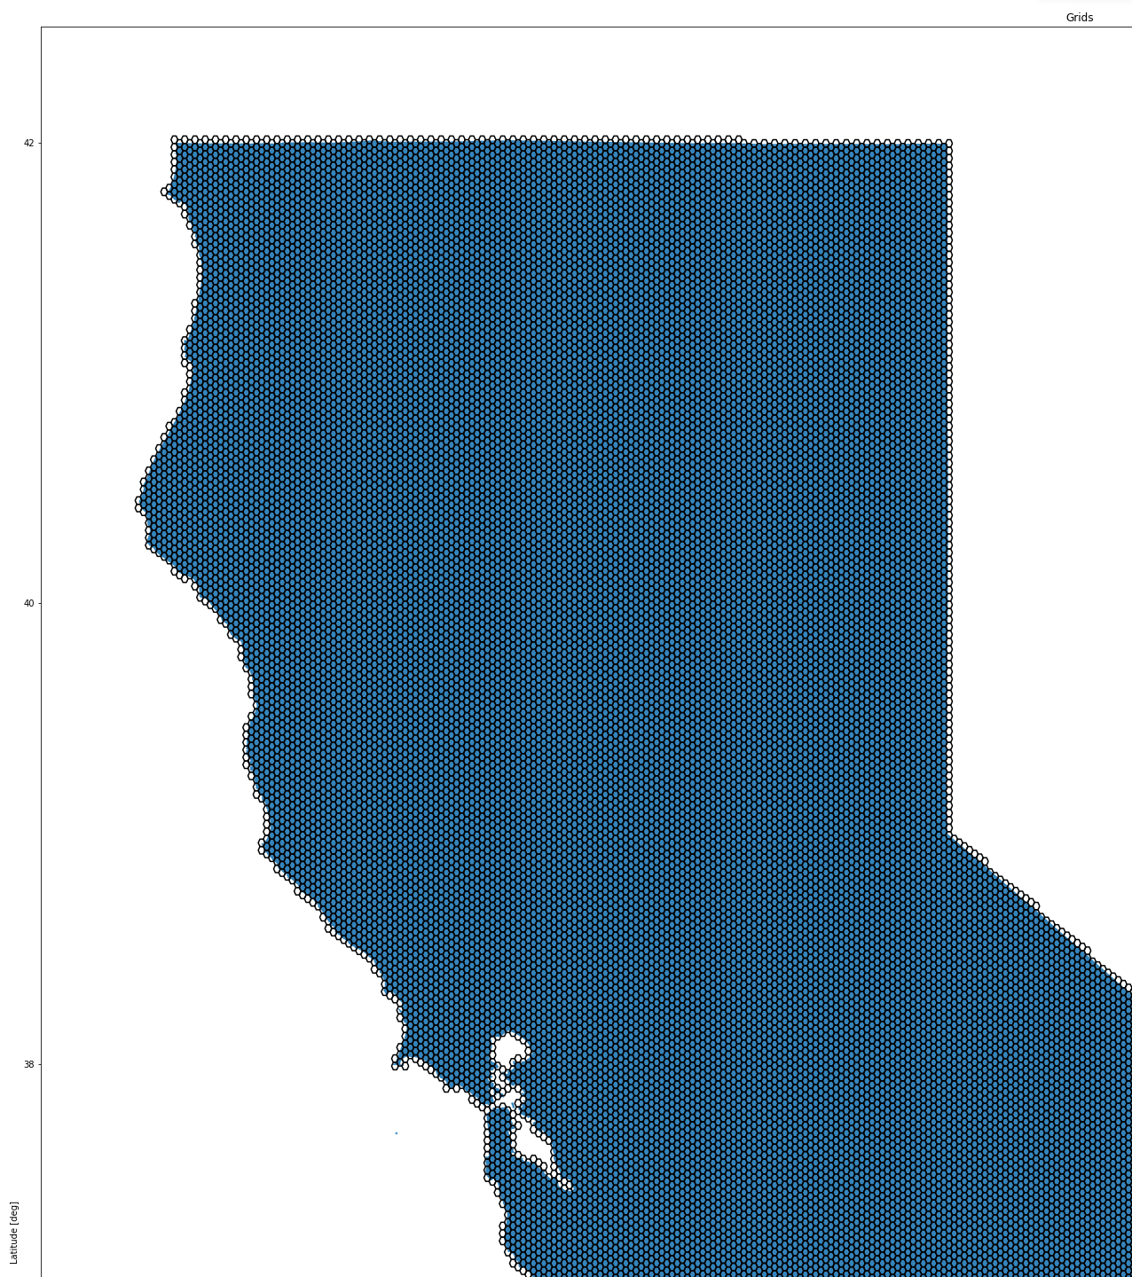

# Maintenance

Added the 10km2 grid to the datasets with column name “grid” the relational table is “ca-grid-hexagons”

Kept the older grid system, which has an area about 127.31km2, with the name ”grid_large” and the relational table “ca-grid-hexagons-large”

Saved all of our tree/bird statistics from before into a BigQuery table if we need to get them later. bird-tree-stats-127km-agg

Redid all plots with 10km^2 grid, and added all to BigQuery table. bird-tree-stats-10km-agg

<https://docs.google.com/document/d/1l3GWdoyL_hpq5uDFHR5EZA6MVYUtKz7JoCuLSr-yoqQ/edit>

# Getting a Population Grid:

<https://dataforgood.facebook.com/dfg/docs/high-resolution-population-density-maps-demographic-estimates-documentation>

<https://data.humdata.org/dataset/united-states-high-resolution-population-density-maps-demographic-estimates>

<https://dataforgood.facebook.com/dfg/docs/methodology-high-resolution-population-density-maps>

Got 6 Population Grid Estimate Datasets from Facebook High Resolution Population Density Maps for the US and added to BigQuery.

Combined the 6 datasets (stacked) and spatially joined to the 10km^2 hexagon grid.

Summed population within each 10km^2 grid

Look at maximum Entropy Modeling

<https://biodiversityinformatics.amnh.org/open_source/maxent/>

Bird Distribution Data:

<http://datazone.birdlife.org/species/requestdis>

**Figure 2**

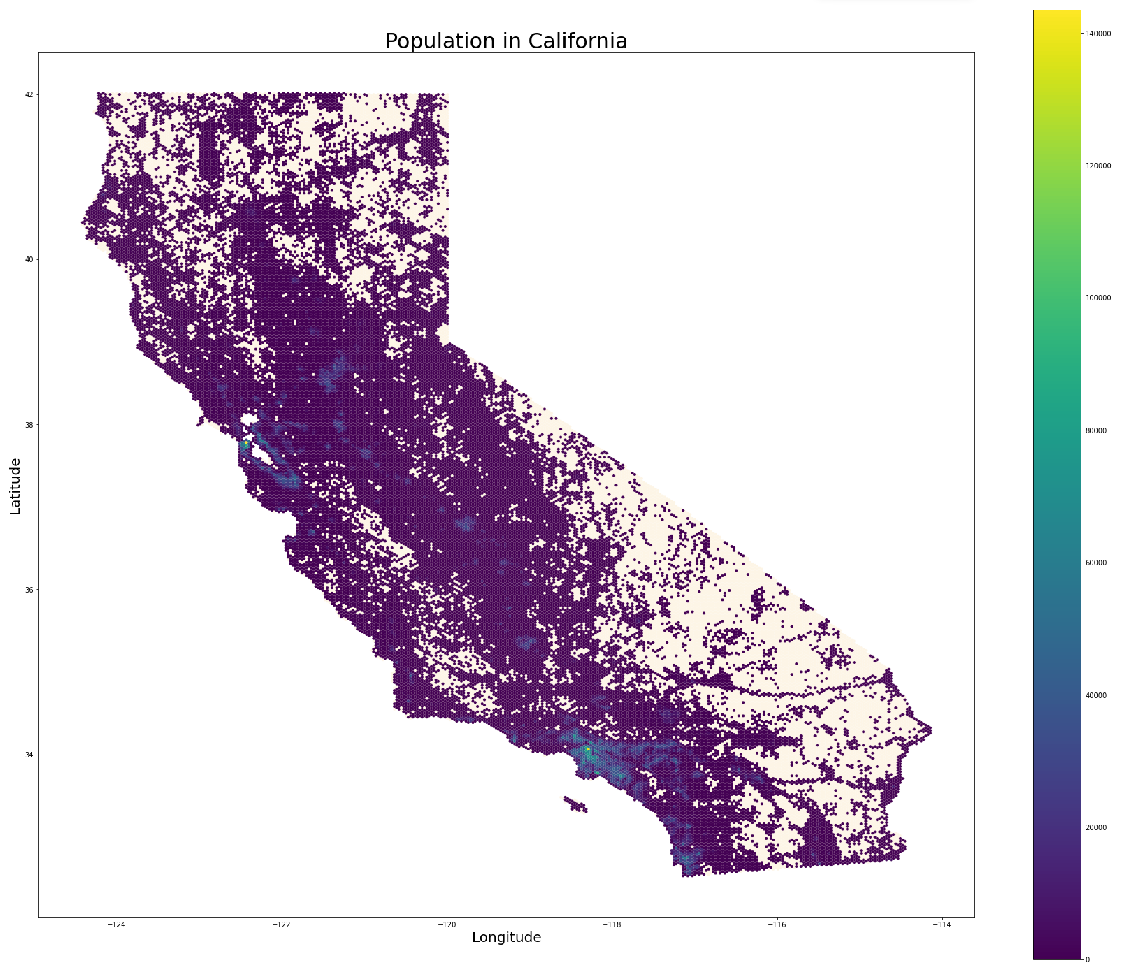

# Choropleth Plots:

**Figure 3**

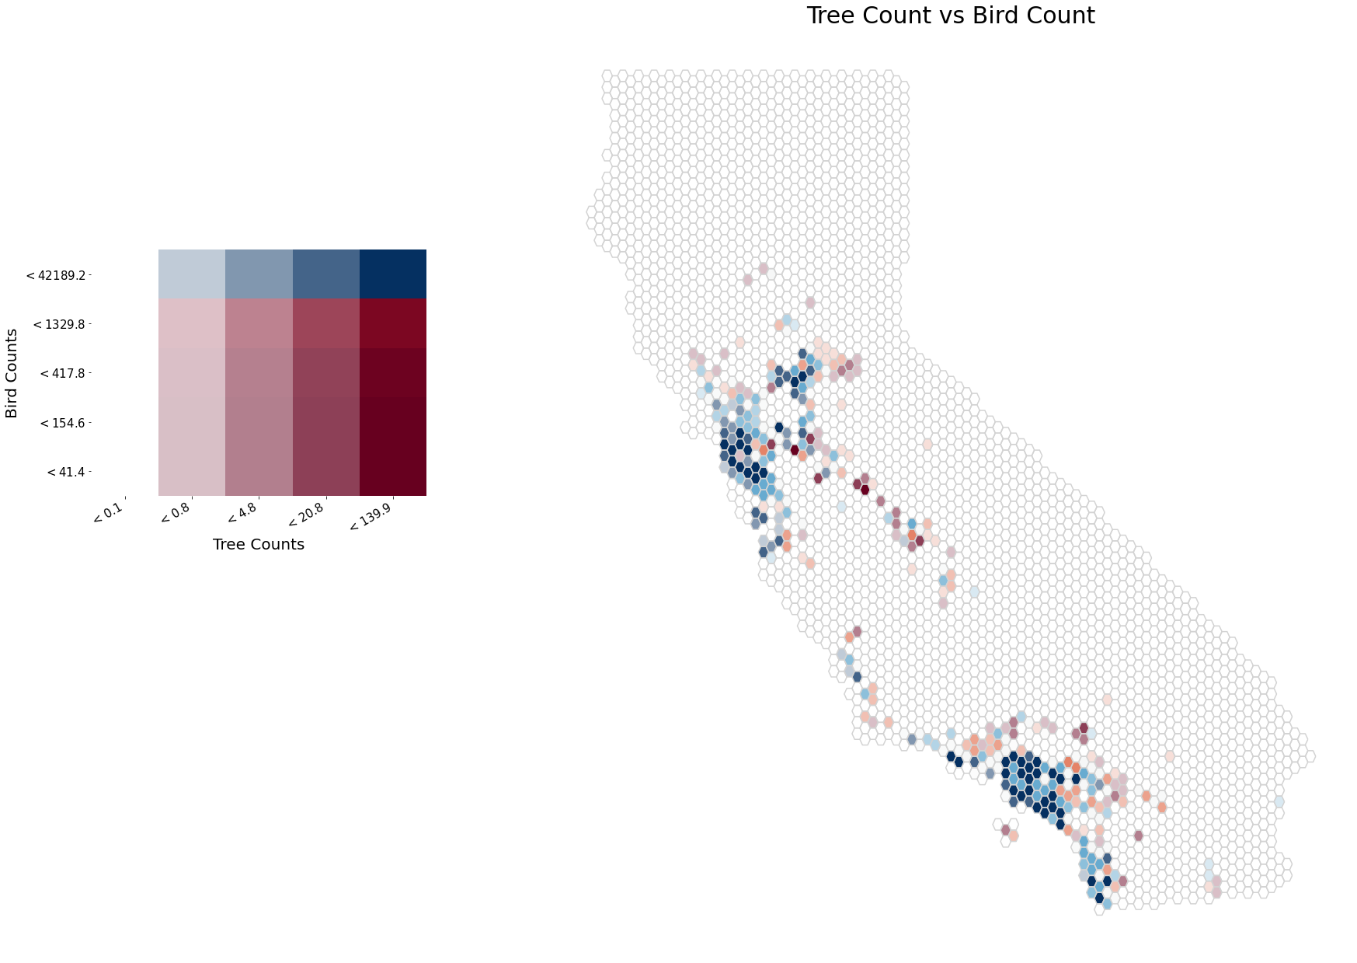

**Figure 4**

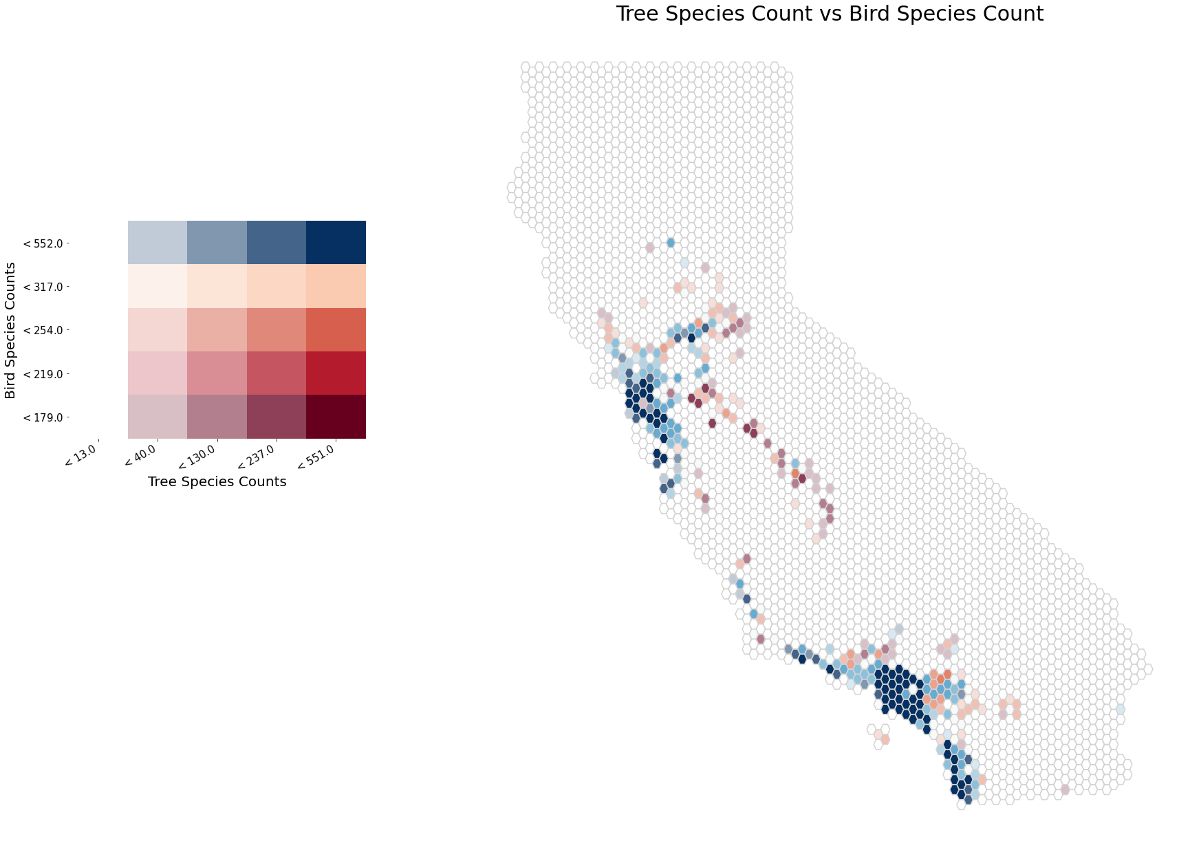

**Figure 5**



**Figure 6**

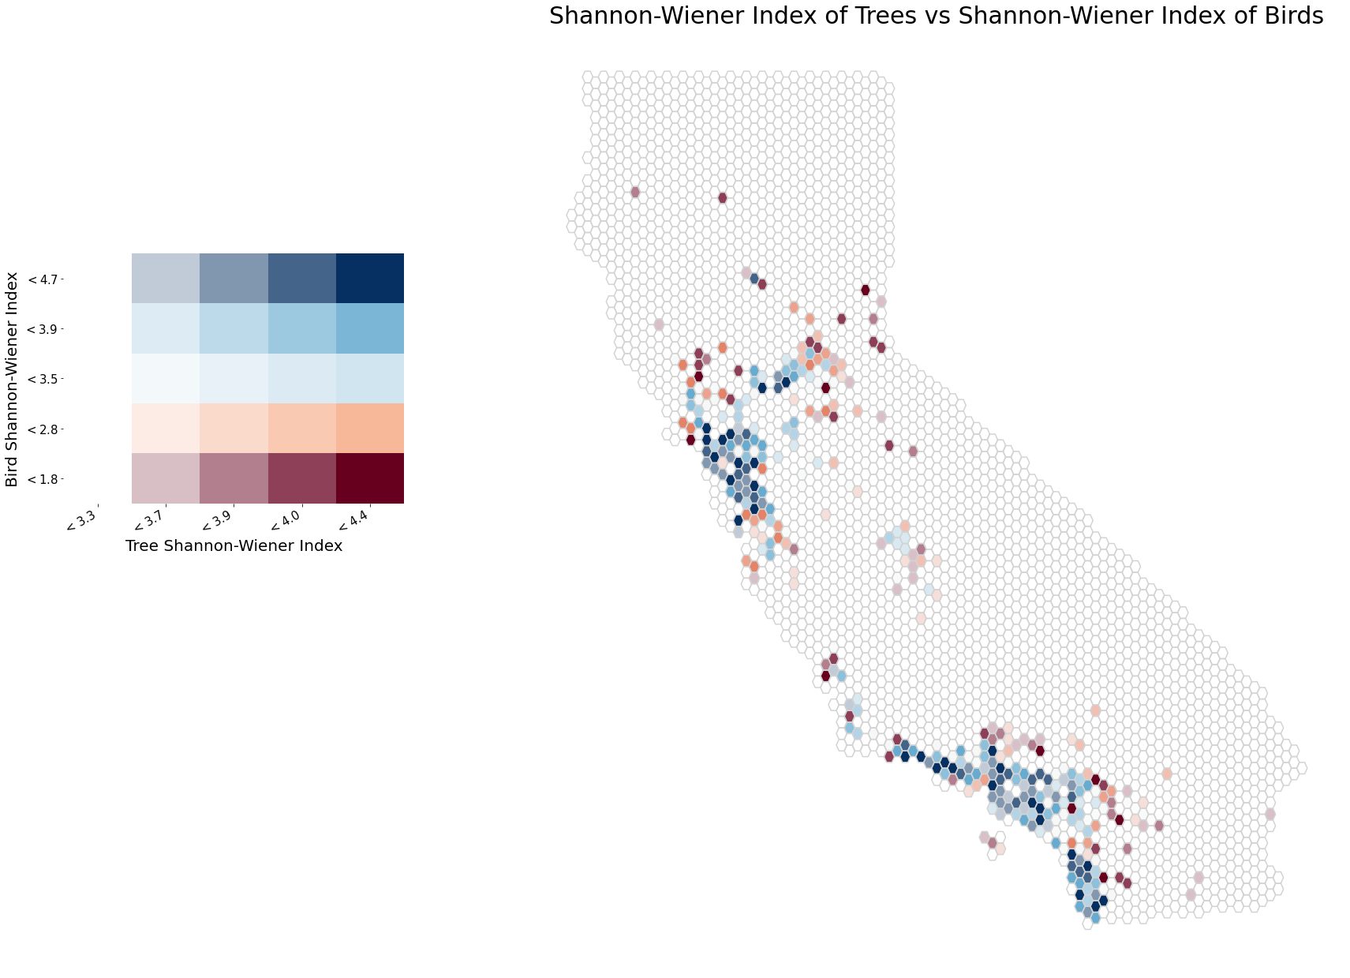

**Figure 7**

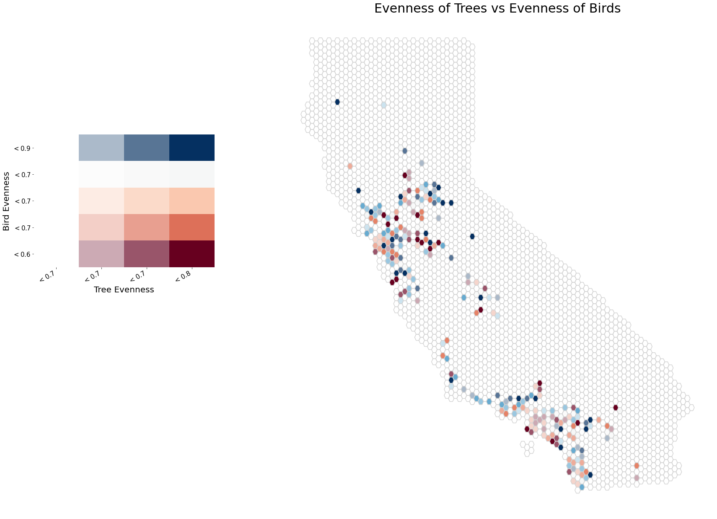

**Figure 8**

